The content of the web (such as your pictures, text, links) will show up here.

**Correct Answer:** Body

**2.** How do I change the size of an image?

**Correct Answer:** width / height

**3.** A tag that does not require a separate closing tag is known as__________.

**Correct Answer:** empty tag

**4.** All images must be saved to this folder

**Correct Answer:** Picture

**5.** Spelling and punctuation are not important when writing code.

**Correct Answer:** False

**6.** File Management is not important in the area of Web Design.

**Correct Answer:** False

**7.** What are the spaces created on a table that holds information called?

**Correct Answer:** cell

**8.** Which of the following is not a web browser?

**Correct Answer:** Youtube

**9.** Which of the following is a body attribute?

**Correct Answer:** All of these are attributes

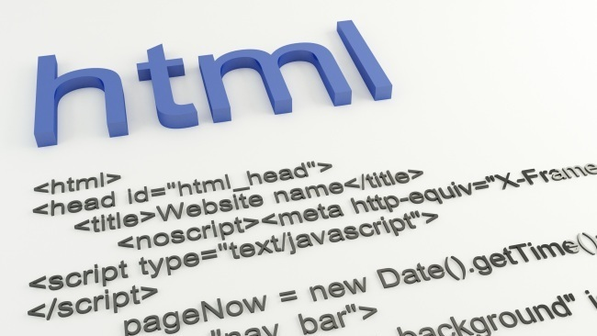

**10.** What is the starting code for adding a picture?

**Correct Answer:** <img src=

**11.** What's another name for W3C?

**Correct Answer:** World Wide Web Consortium

**12.** What is the correct HTML element for inserting a line break?

**Correct Answer:** <br/>

**13.** How many images can be inserted on a website?

**Correct Answer:** As many as you want

**14.** What does <OL> stand for?

**Correct Answer:** Order-List

**15.** The following tag will show a bulleted list

**Correct Answer:** <ul>

**16.** Which tag is used to enter data into a table?

**Correct Answer:** <table>

**17.** Which tag is used to create a hyperlink?

**Correct Answer:** <a>

**18.** Which one of these tags is closed?

**Correct Answer:** </head>

**19.** To make a comment in HTML you use

**Correct Answer:** <!--  -->

**20.** How do I finish this code to change the background color with CSS?  
<body

**Correct Answer:** style="background-color:red ">

**21.** Where can images be inserted on a website?

**Correct Answer:** All of these

**22.** Which of the following is the largest heading?

**Correct Answer:** H2

**23.** Which is the correct syntax to create a link?

**Correct Answer:** <a href=  
"www.facebook.com">  
Facebook  
</a>

**24.** What HTML element defines the title of the document?

**Correct Answer:** <title>

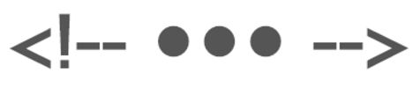

**25.** This symbol means WHAT in HTML?

**Correct Answer:** comment

**26.** What should be modified in a hyperlink to make it open into a new window?

**Correct Answer:** target

**27.** What is the function of the <p> tag?

**Correct Answer:** Defines a paragraph.

**28.** What tag is used for CSS?

**Correct Answer:** <style>

**29.** What does href attribute stand for?

**Correct Answer:** Hypertext Reference

**30.** Which tag is used to create a new column within a table?

**Correct Answer:** <td>

**31.** What is <OL> used for?

**Correct Answer:** Numbers

**32.** Which attribute specifies where to open the linked webpage?

**Correct Answer:** target

**33.** Name an element which doesn't have a closing tag.

**Correct Answer:** <img>

**34.** What is wrong with this code?   
<h1> Miss Mandy    <p> is really cool </p>

**Correct Answer:** It is missing a closing statement

**35.** What needs to be done when we are done with a tag?

**Correct Answer:** Close it

**36.** What is the correct syntax for inserting an image?

**Correct Answer:** <img src="untitled.jpg"/>

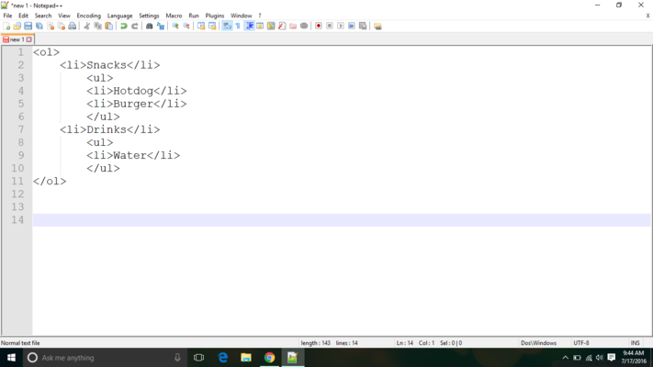

**37.** Which will be the output of these codes?

**Correct Answer:** 1. Snacks  
                         • Hotdog  
                         • Burger  
2. Drinks  
                         • Water

**38.** The tag will not show up on your webpage but at the top of a browser.

**Correct Answer:** Title

**39.** They are simple, easy-to-use programs which allow you to enter, edit, save, and print text.

**Correct Answer:** text editor

**40.** What is the tag used for adding series of hyperlinks?

**Correct Answer:** <nav><nav/>

**41.** Which tag is used to create a new row in a table?

**Correct Answer:** <tr>

**42.** Which web image format supports animation?

**Correct Answer:** GIF

**43.** Which tag is used to create links?

**Correct Answer:** <a> </a>

**44.** The ___ tag set provides information to the browser about your webpage including the author name and keywords.

**Correct Answer:** <meta></meta>

**45.** Which tag defines a numbered list?

**Correct Answer:** OL

**46.** The default link color for hyperlinks:

**Correct Answer:** blue

**47.** You should save HTML files with which file extension?

**Correct Answer:** .html

**48.** What does HTML stand for?

**Correct Answer:** Hypertext Markup Language

**49.** Where do you place documents pertaining to a particular webpage?

**Correct Answer:** Folder

**50.** What Are The Last 2 Tags On Every Website ?

**Correct Answer:** <html> <body>

**51.** HTML helps in which way?

**Correct Answer:** Defining a page structure

**52.** What does <hr/> stand for?

**Correct Answer:** Horizontal rule

**53.** When a tag is used inside of another tag this is known as?

**Correct Answer:** Nesting

**54.** Which tag is used to make text italicized?

**Correct Answer:** <em>

**55.** What are web pages stored on?

**Correct Answer:** Web servers

**56.** If I wanted to bold my text, I would use what tag?

**Correct Answer:** <strong>

**57.** Defines a division or a section in an HTML document. Used to group block-elements to format them with CSS

**Correct Answer:** <div>

**58.** Which uses hexadecimals?

**Correct Answer:** colors

**59.** What does <Li> stand for?

**Correct Answer:** List-Item

**60.** What symbol should precede hexadecimal color codes?

**Correct Answer:** number sign

**61.** Images in your webpage may have the following extensions except

**Correct Answer:** .psd

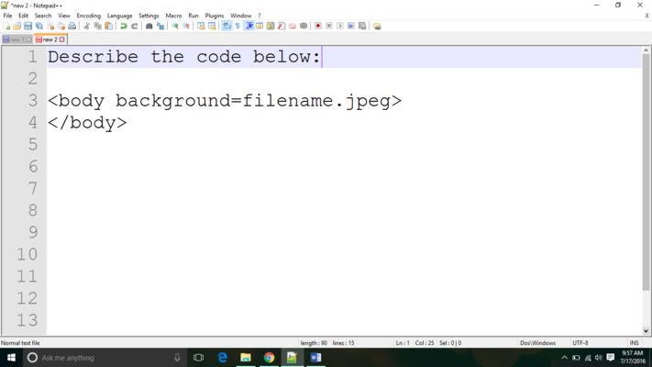

**62.** The above code is ____________.

**Correct Answer:** Missing Symbols